JNNSMEE - 2019

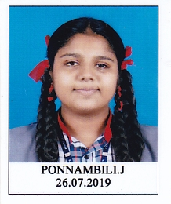

Miss. PONNAMBILI J , IX A QUALIFIED KVS RO LEVEL JNNSMEE – 2019 AND WILL PARTICIPATE KVS NATIONAL JNNSMEE – 2019 AT KV BHOPAL UNDER THE SUBTHEME " SUSTAINABLE AGRICULTURE ".

