PM SHRI KENDRIYA VIDYALAYA PAYYANNUR

HOLIDAY HOMEWORK – CLASS XI Mathematics

1. A general election of Lok Sabha is a gigantic exercise. About 911 million people were eligible to vote and voter turnout was about 67%, the highest ever Let I be the set of all citizens of India who were eligible to exercise their voting right in general election held in 2019.

A relation ‘R’ is defined on I as follows: R = {(𝑉1, 𝑉2) ∶ 𝑉1, 𝑉2 ∈ 𝐼 and both use their voting right in general election – 2019}

(i) Two neighbors X and Y∈ I. X exercised his voting right while Y did not cast her vote in general election – 2019. Which of the following is true?

1. (X,Y) ∈R b. (Y,X) ∈R c. (X,X) ∉R d. (X,Y) ∉R

(ii) Mr.’𝑋’ and his wife ‘𝑊’both exercised their voting right in general election -2019, Which of the following is true?

a. both (X,W) and (W,X) ∈ R

b. (X,W) ∈ R but (W,X) ∉ R

c. both (X,W) and (W,X) ∉ R

d. (W,X) ∈ R but (X,W) ∉ R

(iii) Three friends F1, F2 and F3 exercised their voting right in general election-2019, then which of the following is true?

a. (F1,F2 ) ∈R, (F2,F3) ∈ R and (F1,F3) ∈ R

b. (F1,F2 ) ∈ R, (F2,F3) ∈ R and (F1,F3) ∉ R

c. (F1,F2 ) ∈ R, (F2,F2) ∈R but (F3,F3) ∉ R

d. (F1,F2 ) ∉ R, (F2,F3) ∉ R and (F1,F3) ∉ R

(iv) Mr. Shyam exercised his voting right in General Election – 2019, then Mr. Shyam is related to which of the following?

a. All those eligible voters who cast their votes b. Family members of Mr.Shyam

c. All citizens of India d. Eligible voters of India

2. Solve the following using the information given bellow

. If Z= x + iy where x & y are real, is a complex number & $\overline{z}= x-iy$ is the complex conjugate of Z & 𝑀𝑜𝑑𝑢𝑙𝑢𝑠 𝑜𝑓 𝑍 𝑜𝑟 |𝑍| =

. i) let Z1= 2+ 3i & 𝑍̅ 2=1+i 23. Modulus of Z1+Z2

ii) Which is correct?

(A) |𝑍1 | = |𝑍2 | (B) |𝑍1 | = |𝑍1 + 𝑍2 | (C) |𝑍1 | = |𝑍1 − 𝑍2 | (D) none of these

Iii ) 𝑍̅ 1𝑍2

3. In drilling world’s deepest hole, the Kola Superdeep Borehole, the deepest manmade hole on Earth and deepest artificial point on Earth, as a result of a scientific drilling project, it was found that the temperature T in degree Celsius, x km below the surface of Earth, was given by:  
T = 30 + 25 (x – 3), 3 < x < 15.  
If the required temperature lies between 200o C and 300o C, then  
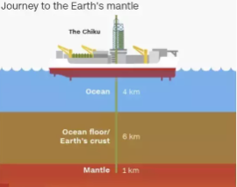

1. the depth, x will lie between
   1. 9 km and 13 km
   2. 9.8 km and 13.8 km
   3. 9.5 km and 13.5 km
   4. 10 km and 14 km
2. Solve for x. -9x+2> 18 OR 13x+15 ≤−4
   1. **x ≤ −1913**
   2. x < −1613
   3. −1613 < x < −1913
   4. There are no solution.
3. **Find the inequality represented by the graph**  
   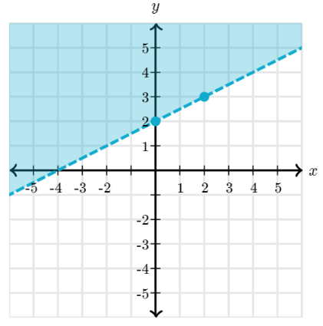
   1. y ≤ 12x+2
   2. y > 12x+2
   3. y ≥ 12x+2
   4. y < 12x+2

4.If |x| < 5 then the value of x lies in the interval

* 1. (-∞, -5)
  2. (∞, 5)
  3. (-5, ∞)
  4. (-5, 5)

5.Graph the following inequality on the number line: x > −32

* 1. https://media-mycbseguide.s3.amazonaws.com/images/imgur/1607587754-2qxxp7.jpg
  2. https://media-mycbseguide.s3.amazonaws.com/images/imgur/1607587756-atntq5.jpg
  3. https://media-mycbseguide.s3.amazonaws.com/images/imgur/1607587759-aw8pjt.jpg
  4. https://media-mycbseguide.s3.amazonaws.com/images/imgur/1607587761-kdeyw9.jpg

4. **Read the Case study given below and attempt any 4 subparts:**  
A state cricket authority has to choose a team of 11 members, to do it so the authority asks 2 coaches of a government academy to select the team members that have experience as well as the best performers in last 15 matches. They can make up a team of 11 cricketers amongst 15 possible candidates. In how many ways can the final eleven be selected from 15 cricket players if:  


1. there is no restriction
   1. 1365
   2. 2365
   3. 1465
   4. 1375
2. one of then must be included
   1. 1002
   2. 1003
   3. 1001
   4. 1004
3. one of them, who is in bad form, must always be excluded
   1. 480
   2. 364
   3. 1365
   4. 640
4. Two of them being leg spinners, one and only one leg spinner must be included?
   1. 2C1×13C10
   2. 2C1×10C13
   3. 1C2×13C10
   4. 2C10×13C10
5. If there are 6 bowlers, 3 wicket-keepers, and 11 batsmen in all. The number of ways in which a  
   A team of 4 bowlers, 2 wicket-keepers, and 5 batsmen can be chosen.
   1. 6C2​×3C4 ×11C5​
   2. 6C2​×3C4 ×11C5
   3. 6C2​×3C5×11C4​
   4. 6C2​ × 3C1​ ×11C5
6. . The below figure shows the compass. The East direction is along the positive X-axis (0° angle) and North direction is along the +ve Y-axis (90° angles). Initially the pointer is pointed towards NorthEast direction. Pointer is deflected in a magnetic field by some angle.

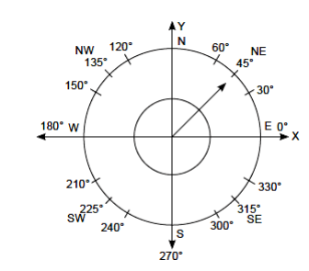On the basis of above answer the following.

* + 1. If pointer move in anticlockwise direction by an angle of 90°, then find the value of sine of angle made by pointer from East direction.
    2. If pointer moves an angle of 165° from its initial position in anticlockwise direction, then find the value of cosine of angle made by pointer from East direction.
    3. If the sine and cosine of angle made by pointer with East direction is $\frac{1}{\sqrt{2}}$

then find where the pointer pointed?

* + 1. How much angle will pointer move in anticlock wise direction if tangent of angle made by pointer with x-axis is – 1?