**PM SHRI KENDRIYA VIDYALAYA PAYYANUR**

**HOLODAY HOMEWORK (2024-25)**

**CLASS: IX SUBJECT: MATHEMATICS**

1. Two classmates Ram and Shyam simplified two different expressions during the revision hour and explained to each other their simplifications.

Ram explains the simplification of $\frac{√2}{\sqrt{5}+√3}$ by rationalising the denominator and Shyam explains the simplification of $(√2+√3)(√2-√3)$ by using an identity. Answer the following questions:

1. What is the conjugate of $√5+√3$
2. By rationalising the denominator, what answer Ram get?
3. Which identity did Shyam use to evaluate $(√2+√3)(√2-√3)$
4. On simplification $√50-√98+√162$ is equal to
5. Which of the following problems could be solved by finding the solution of the given system?

2x+2y=56, $y=\frac{1}{3}x$

1. The area of a rectangle is 56 sq. unit. The width is one-third the length. Find the length of the rectangle.
2. The area of the rectangle is 56 sq. unit. The length is one-third the perimeter. Find the length of the rectangle.
3. The perimeter of the rectangle is 56 unit. The length is one-third more than the width. Find the length of the rectangle.
4. The perimeter of a rectangle is 56 unit. The width is one-third the length. Find the length of the rectangle.
5. A school of Delhi decided different types of tours for the students to educate them. So, in class IX $1/{12}th$ times the square of the total number of students planned to visit historical monuments. $7/{12}th$ times the number of students planned to visit old age homes while 15 students decided to teach poor children.
6. Using above information express the total number of students as a polynomial in terms of x
7. Write the coefficient of x in the polynomial.
8. Write the coefficient of $x^{2}$ in the polynomial.
9. Find the value of p(x) at x=2
10. The class IX students of a secondary school in Haryana have been allotted a rectangular plot of land for their gardening activity. Sapling of Gulmohar are planted on the boundary at a distance of 1m from each other. There is a lawn PQRS in the ground as shown in below figure.

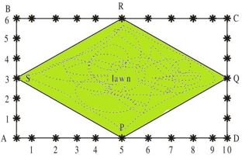

1. What are the coordinates of C, taking A as origin?
2. What are the coordinates of R, taking A as origin?
3. Find the Side of lawn.
4. Find the area of the lawn.
5. **Deepak** bought 3 notebooks and 2 pens for Rs. 80. His friend Ram said that price of each notebook could be Rs. 25. Then 3 notebooks would cost Rs. 75, the two pens would cost Rs.5 and each pen could be for Rs. 2.50. Another friend Ajay felt that Rs. 2.50 for one pen was too little. It should be at least Rs. 16. Then the price of each notebook would also be Rs.16.

**Rohit** also bought the same types of notebooks and pens as Deepak. He paid 110 for 4 notebooks and 3 pens. Later, Deepak guess the cost of one pen is Rs. 10 and Rohit guess the cost of one notebook is Rs. 30



1. Form the pair of linear equation in two variables from this situation by taking cost of one notebook as Rs. x and cost of one pen as Rs. Y
2. Find the solution which satisfying both the equation formed in (a)?
3. Find the cost of one pen?
4. Find the total cost if they will purchase the same type of 15 notebooks and 12 pens.
5. Once 4 students from class IX were selected for plantation of flower plants in the school garden. The selected students were Pankaj, Raju, Deepak and Renu. As shown PQ and MN are the parallel lines of the plants. Pankaj planted a sunflower plant at P and Raju planted another sunflower at Q. Further Deepak was called to plant any flowering plant at point M he planted a marigold there now it was the turn of Renu, she was told to plant a flowering plant different from the three planted one. So, she planted a rose plant at N. There was a water pipe line XY which intersected PQ and MN at A and B and,∠XBN=60

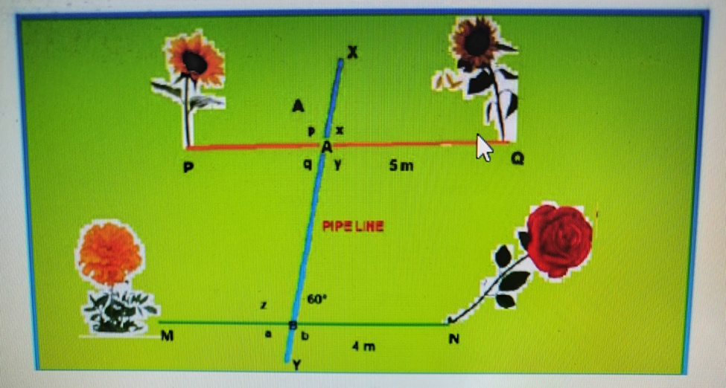

1. What is the value of z?
2. What is the value of x?
3. What is the value of p + q?
4. Which angle is the corresponding angle to a?
5. What is the value of (p+q+a+z)/6?